UNITED STATES OF AMERICA
BEFORE THE
FEDERAL ENERGY REGULATORY COMMISSION

State of California, ex rel. Bill Lockyer,  Attorney General of the State of California  v.  British Columbia Power Exchange Corporation,  Coral Power, LLC, Dynegy Power  Marketing, Inc., Enron Power Marketing,  Inc., Mirant Americas Energy Marketing, LP,  Reliant Energy Services, Inc., Williams  Energy Marketing & Trading Company,  All Other Public Utility Sellers of Energy and  Ancillary Services to the California Energy  Resources Scheduling Division of the  California Department of Water Resources, and  All Other Public Utility Sellers of Energy and  Ancillary Services into Markets Operated by the  California Power Exchange and California  Independent System Operator | Docket No. | EL02-71-017
TESTIMONY OF MICHAEL E. BOYD FOR
CALIFORNIANS FOR RENEWABLE ENERGY, INC. (CARE)

Attached is the CAlifornians for Renewable Energy, Inc. (CARE) testimony of Michael E. Boyd included is a Declaration.

Respectfully submitted,
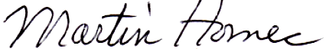

Martin Homec
P. O. Box 4471
Davis, CA 95617
Tel.: (530) 867-1850
E-mail: martinhomec@gmail.com
Attorney for CARE

July 1, 2009

Verification
I am an officer of the Intervening Corporation herein, and am authorized to make this verification on its behalf. The statements in the foregoing document are true of my own knowledge, except matters, which are therein stated on information and belief, and as to those matters I believe them to be true.
I declare under penalty of perjury that the foregoing is true and correct.
Executed on July 1, 2009, at San Francisco, California.
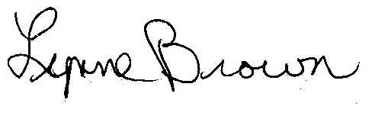
__________________________
Lynne Brown Vice-President
CAlifornians for Renewable Energy, Inc. (CARE)

Certificate of copy sent electronically
To reduce the burden of service in this proceeding, the Commission will allow the use of electronic service, to the extent possible using the electronic service protocols provided in this proceeding. All individuals on the service list should provide electronic mail addresses. The Commission and other parties will assume a party consents to electronic service unless the party indicates otherwise.
Each person designated on the official service list, has been provided a copy via e-mail, to all persons on the attached service list on July 1, 2009 for the proceedings, EL02-71-017.
__________________________
Lynne Brown Vice-President
CAlifornians for Renewable Energy, Inc. (CARE)
24 Harbor Road
San Francisco, CA 94124
Phone: (415) 285-4628
E-mail: l_brown369@yahoo.com

EL02-71-017 Electronic Service List
ksalvagno@wellhead.com, aklodow@alleghenyenergy.com, gmathews@edisonmission.com, sean.beatty@mirant.com, douglass@energyattorney.com, girish_balachandran@city.palo-alto.ca.us, lisa.decker@constellation.com, don.kaplan@klgates.com, donald.heydt@ferc.gov, mvkirkwood@jonesday.com, jadillon@pplweb.com, myuffee@mwe.com, randy.mcmanus@bakerbotts.com, scottst@mid.org, ken.alex@doj.ca.gov, haskell@bh-law.com, etwomey@mofo.com, robert.neate@pse.com, GDB@VNF.com, erin.moore@sce.com, cgiovann@steptoe.com, bray.dohrwardt@directenergy.com, cross@bc-law.net, KJLipson@HHLAW.com, dws@r-c-s-inc.com, Alexm@calpine.com, e-recipient@caiso.com, David.Rubin@troutmansanders.com, david.hudson@xcelenergy.com, hcurlee@sidley.com, mark.woodruff@aes.com, jennifer.lehmann@aes.com, Jodi.Moskowitz@PSEG.com, rjda@pge.com, sberman@sidley.com, dnelson@gwfpower.com, gdo@duncanallen.com, gfergus@ferguslegal.com, kaplan@iepa.com, abb@eslawfirm.com, shg@cpuc.ca.gov, aro@cpuc.ca.gov, sterling_koch@transalta.com, sangle@velaw.com, Timothy.Bolden@pinnaclewest.com, jmcgrane@morganlewis.com, jmccaffrey@stinson.com, rreilley@coral-energy.com, dan.watkiss@bgllp.com, keith.mccrea@sutherland.com, will.patton@seattle.gov, pnowak@akingump.com, bob.lafferty@avistacorp.com, ek@a-klaw.com, grant.kolling@cityofpaloalto.org, jdp@dwgp.com, Noel.trask@exeloncorp.com, kjmcintyre@jonesday.com, rwuslich@winston.com, Cheryl.chevis@pgn.com, cmfoley@skadden.com, bill.dudley@xcelenergy.com, steve.weiler@leonard.com, kristine_delkus@transcanada.com, kwiseman@andrewskurth.com, gortman@stinson.com, fallonr@dicksteinshapiro.com, jimross@r-c-s-inc.com, hollis.alpert@ferc.gov, cfr@vnf.com, ehahn@mwdh2o.com, bkm@dwgp.com, dmahmud@mwdh2o.com, ndr@dwgp.com, emyerskerbal@shb.com, edith.gilmore@ferc.gov, donald.heydt@ferc.gov, linda.boner@ferc.gov, mrw@mrwassoc.com, dking@sempra.com, michaeledwardboyd@sbcglobal.net, aclair@stinson.com, SNelson@sempra.com, ayudkowsky@stroock.com, dhecht@sempratrading.com, mam@vnf.com, pjburger@bpa.gov, dlamoreaux@tep.com, jeffrey.jakubiak@troutmansanders.com, Charles.Garcia@PNMResources.com, jeff.erb@pacificorp.com, sschotland@cgsh.com, jestes@skadden.com, relliott@mbolaw.com, jhmartin@stoel.com, stl@dwgp.com, pjs@dwgp.com, betsy.carr@dynegy.com, dfrances@skadden.com, epwitkos@ag.state.nv.us, bremer@wapa.gov, kjbarr@srpnet.com, dswanstrom@pattonboggs.com, debra.bolton@mirant.com, david.tewksbury@lw.com, PGS@IEEE.org, rcarroll@foley.com, twoodworth@nvenergy.com, llarson@balch.com, fnorton@morganlewis.com, jhmcgrew@brudergentile.com, rloeffler@mofo.com, eelrod@sidley.com, brogan.sullivan@aquila.com, Curtis.Blanc@kcpl.com, kirvin@mwe.com, mrp@dwgp.com, arb@dwgp.com, teresa.conway@powerex.com, paul.fox@bracewellgiuliani.com, kurman.michael@arentfox.com, fallonr@leonard.com, grosenblum@eob.ca.gov, hes@vnf.com, dshaw@pierceatwood.com, bsnyder@dl.com, lacker@dl.com, vbf@vnf.com, msc@vnf.com, rmarooney@kslaw.com, cstites@mwdh2o.com, mdp5@pge.com, aestes@balch.com, davidbrown@JonesDay.com, troy.phillips@mail.house.gov, Michael_Weiss@boxer.senate.gov, matthew_nelson@feinstein.senate.gov, senator@boxer.senate.gov,

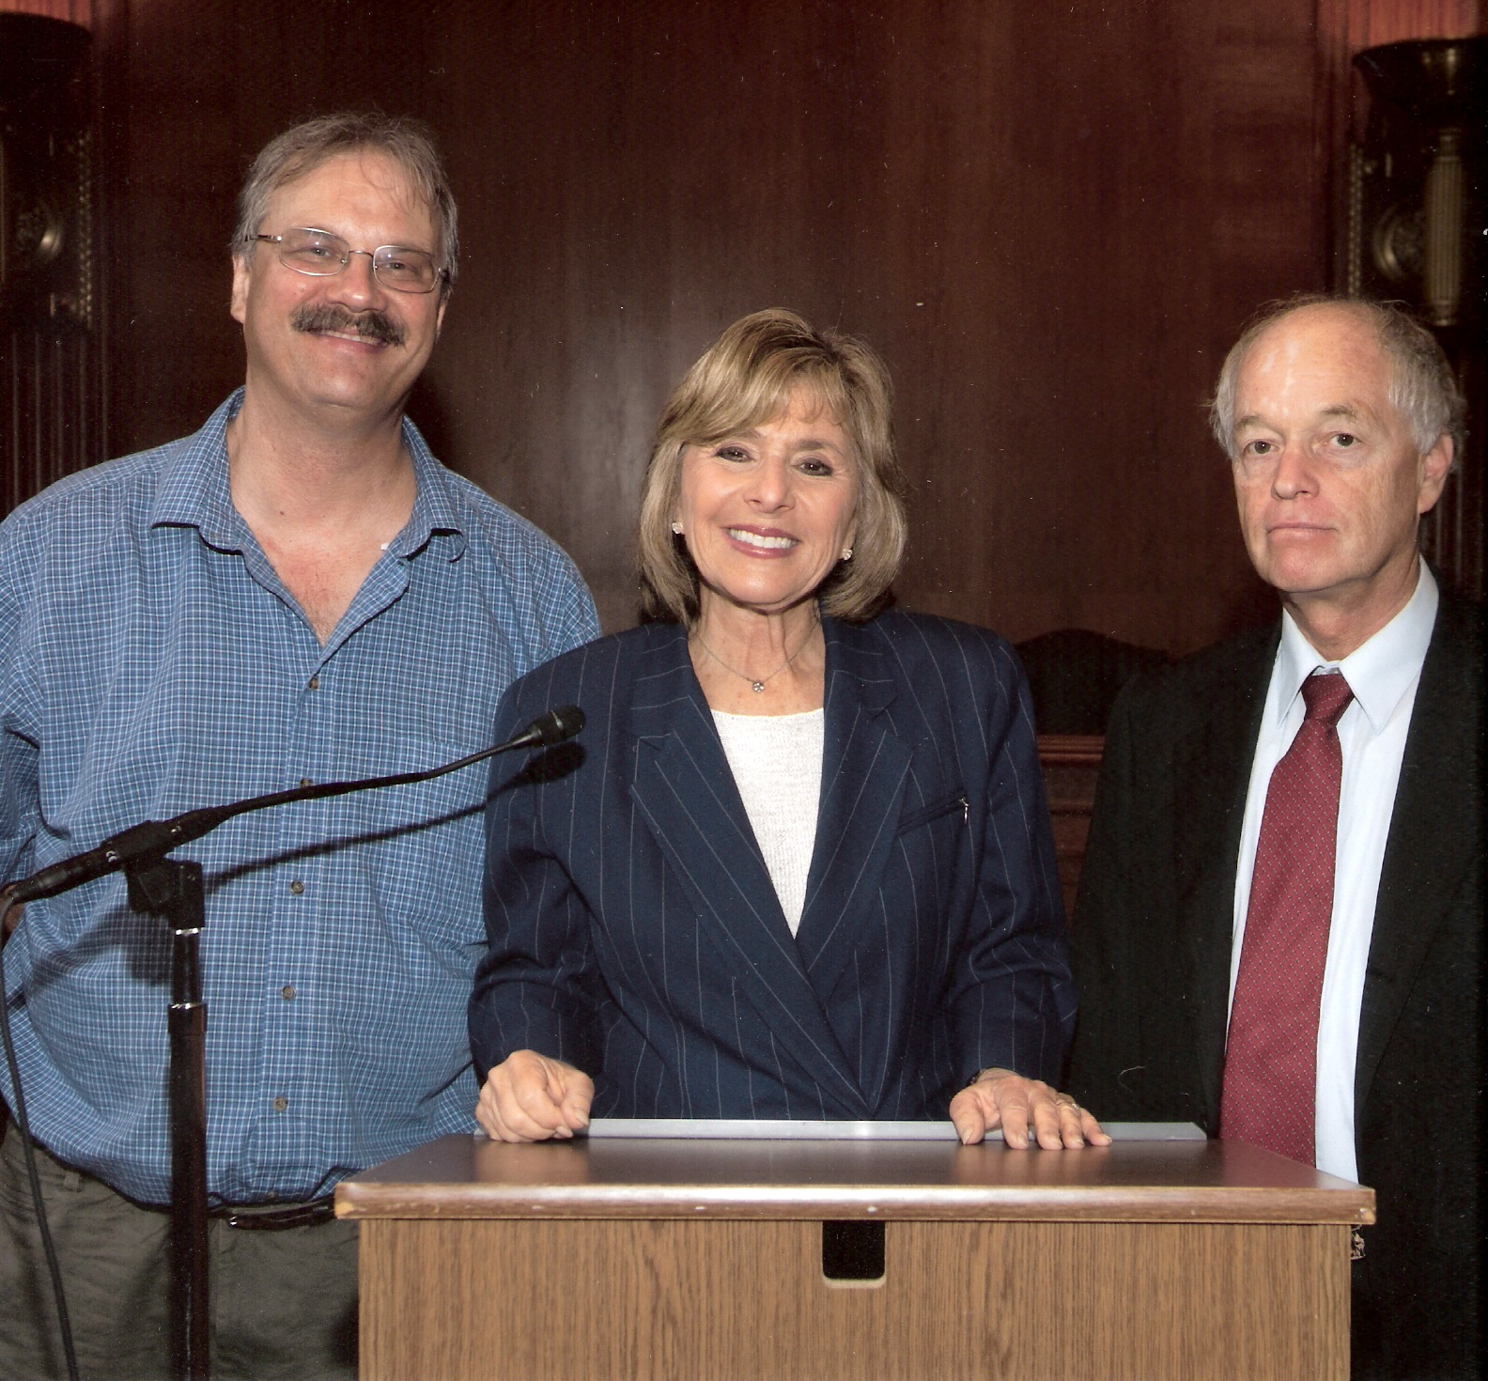
From left to right: CARE's President Michael Boyd, California Senator Barbara Boxer, and CARE's Attorney Martin Homec (June 10, 2009 picture)
Testimony of Michael E. Boyd
June 30, 2009
The purpose of my testimony is to identify if there exists any data that has been presented as a result of market participant quarterly transaction information provided to CARE in the EL02-71-017 proceedings to demonstrate if there is any evidence that the exercise of market power had taken place during the 2000 through 2001 western energy crisis. My conclusions are based on the data in my possession. I can only demonstrate that Pacific Gas and Electric Company (PG&E) had the opportunity and ability to exercise market power and based on this data PG&E confiscated more than six billion dollars in excess profits from California ratepayers for the price of electricity it sold in to the California Power Exchange (PX) in 2000 and in the ISO Markets in 2000 and 2001. The role of the California Department of Water Resources (“CDWR”) and the State of California in "cramming" an additional forty three billion dollars worth of long term energy contract charges on California electricity customer's by the state's utility is also included in my testimony.
CARE’s efforts were the only direct ratepayer participation
CARE is a party and an active participant in these proceedings related to the 2000-1 western energy crisis. The FERC decisions addressing the 2000-1 western energy crisis did not hold hearings settlement negotiations or other proceedings that included the affected ratepayers. CARE’s efforts were the only direct ratepayer participation. All the other parties to the proceedings were regulated utility companies, energy commodity traders, governmental “non-public utilities” and state and federal government agencies that implemented the policies and practices leading to the energy crisis.
In the Order on rehearing, motion for conditions and compliance filing re Duke Energy Trading and Marketing, L.L.C. et al under EL03-152 et al., 126 FERC ¶ 61,234 (March 19, 2009), the Commission stated:
CARE cites to 16 U.S.C. § 2602(5), which is a PURPA provision, but our action here is pursuant to the FPA and not PURPA. In any event, even if CARE’s citation were relevant, CARE is not the only ratepayer advocate. For example, the California Public Utilities Commission (CPUC), which is one of the California Parties, represents California ratepayers.[] We find that the CPUC’s participation in these proceedings belies CARE’s claim that ratepayers were excluded.[] [Footnotes not provided]
CARE is currently challenging this finding before the US Court of Appeals for the Ninth Circuit, Docket No. 09-71515. This finding conflicts with the “factual basis” for the Commission’s prior rulings on this issue – viz, that the CPUC and CDWR are both agents and representatives of the State of California –were not at issue or disputed. See Pub. Utils. Comm’n of Cal. v. Sellers of Long Term Contracts, 105 FERC 61,182 at 51 (2003) (“Complainants, like CDWR, are agents of the State of California”). Nor can it be disputed that the CPUC did not negotiate or sign these contracts. What remains at issue, in this remanded case, is the Commission’s determination that the legal effect of these facts under California law, is that the CPUC somehow “stepped into the shoes” of CDWR and therefore must be considered a contracting party.
These facts have created the irreconcilable conflict between the CPUC's roles as a “State regulatory authority” to protect the interests of “electric consumer[s]” with the California Energy Resources Scheduling division of the California Department of Water Resources ("CERS") as an “electric utility”. The terms “electric consumer” and “electric utility” have the meanings given those terms in section 2602 of title 16. Therefore, CARE’s efforts were the only direct ratepayer participation without the influence of their conflicting role as a market participant.
Exercise of market power
On July 1, 2002 PG&E submitted a response to a May 31, 2002 Order on Complaint, 99 FERC 61,247 (2002) in the above captioned proceedings (FERC submission 200020705-0036), directing all public utilities that made short-term sales at market-based rates to the California Department of Water Resources (CERS) or in to the California Independent System Operator (ISO) or the California Power Exchange (PX) since October 2, 2000 up to May 31, 2002, to file new quarterly transaction reports.
Prior to this letter PG&E had not filed Quarterly Reports purportedly because "PG&E's authority to sell electric energy at market-based rates into the PX and ISO was granted, subject to mitigation and monitoring requirements, in the Commission's order issued on October 30, 1997, Pacific Gas and Electric Co., et al., 81 FERC 61,122 (1997) (October 30, 1997 Order). That order also approved in large part the ISO and PX Tariffs. Under the October 30, 1997 Order, no quarterly transaction reporting requirement was imposed on PG&E..."
Prior to January 2001, most California consumers were sheltered from the full
deregulation disaster by the statutory rate freeze enacted by the 1996 deregulation law at the behest of the utility companies. However, contrary to the propaganda of the free market ideologues, the retail rate freeze was not intended to shield residential ratepayers from the risks of deregulation. Neither the utilities, nor then-Governor Pete Wilson, nor California lawmakers had the interests of consumers in mind back in 1996 when they pushed the deregulation legislation through a process besotted with millions of dollars from the energy industry. The rate freeze was designed to keep California rates at pre-deregulation levels that were 40% above the national average. The difference between the frozen rate and the actual cost of electricity was pocketed by the state’s three utilities allegedly in order to pay off previous debts – largely from cost overruns on nuclear plant construction in the 1970s – that would otherwise render the electricity sold by California’s three utilities uncompetitive in a deregulated environment. The total cost to ratepayers of the first bailout: $23.6 billion. After collecting the overcharge from ratepayers, more than $4 billion each was removed from the PG&E and Edison utilities by then recently-created parent companies, and then spent on a global shopping spree.
On October 6, 2000 CAlifornians for Renewable Energy, Inc. (CARE) filed its complaint (FERC Submittal 20001010-0051) under docket EL01-2 et al., against "Independent Energy Producers, Inc. and All Sellers of Energy and Ancillary Services Into the Energy and Ancillary Services Markets Operated by the California Independent System Operator Corporation and the California Power Exchange; All Scheduling Coordinators Acting On behalf of the Above Sellers; California Independent System Operator Corporation; and California Power Exchange Corporation".
Pursuant to Section 206 of the Federal Power Act, 16 U.S.C. § 824e, and Rule 206 of the Commission’s Rules of Practice and Procedure, 18 C.F.R. § 385.206, CAlifornians for Renewable Energy, Inc. (CARE) hereby petitions the Commission to rectify unjust and unreasonable prices stemming from the wholesale markets for energy and ancillary services operated by the California Independent System Operator (CAISO) and the California Power Exchange (CalPX). CARE requests that the Commission find that wholesale markets in California are not currently workably competitive. CARE hereby petitions the Commission make findings that the events and circumstances surrounding the June 14, 2000 rolling outage in the San Francisco Bay Area warrant investigation by the United States Department of Justice of trust activities in restraint of trade by Independent Energy Producers, all sellers of energy and ancillary services into energy and ancillary services markets operated by the California Independent System Operator and the California Power Exchange; all scheduling coordinators acting on behalf of aforementioned sellers; California Independent System Operator Corporation; and the California Power Exchange. CARE hereby petitions the Commission make findings that the events and circumstances surrounding the June 14, 2000 rolling outage in the San Francisco Bay Area warrant investigation by the United States Department of Justice of alleged civil rights violations, by Independent Energy Producers, all sellers of energy and ancillary services into energy and ancillary services markets operated by the California Independent System Operator and the California Power Exchange; all scheduling coordinators acting on behalf of aforementioned sellers; California Independent System Operator Corporation; and the California Power Exchange. CARE petitions that said investigation include the identification of injury, loss of life, disability, or hospitalization associated with the June 14, 2000 rolling outage. CARE requests that this complaint be consolidated with Commission Dockets EL00-95-000, EL00-98-000, and EL00-104-000. CARE has not used any of the Commission’s alternative dispute resolutions services (ADR) described in Rule 206(b)(9) and believes that the nature of the complaint is such that ADR will not be useful.
On October 30, 2000 CARE amended its complaint EL01-2 et al., (FERC Submittal 20001102-0005) to include "the major investor-owned distribution utilities (San Diego Gas & Electric, Southern California Edison, and Pacific Gas & Electric)." This is when CARE first brought it claims against the PX and ISO market participants including the three California IOUs before the FERC in behalf of western electricity market consumers.
In 2000, eight wholesale energy companies that purchased a third of California’s power plants after deregulation began apparently decided that they wanted to reap some of the windfall being raked in by the utilities. When wholesale prices soared in 2000, the rate freeze, intended to be a floor, became a ceiling. This was a potentiality that the deregulation law anticipated, but the utilities apparently never expected. The utilities quickly ran out of money. At that point, the parent companies, which had siphoned off much of the windfall from the earlier bailout, decided to walk away from the utilities’ debts. Instead of fulfilling their legal obligation to prioritize the financial health of their utility subsidiaries, the companies demanded that the rate freeze be lifted retroactively and ratepayers be forced to pay the utilities’ losses.
One can also question the prudence of certain transactions between PG&E, its parent company and affiliates that have significantly contributed to its financial problems. Historically, cash has flowed in only one direction—from PG&E to its parent. In the Analysis of Barrington-Wellesley Group’s [BWG] Review of Pacific Gas and Electric Company’s Financial Condition on "page VI-4, BWG confirms that between 1997 and the third quarter of 2000 PG&E transferred more than $4.7 billion to its parent company. BWG notes that these transfers were for specific purposes such as repurchasing stock ($2.8 billion) and paying dividends ($1.9 billion). Because BWG does not provide information for the years before 1997, we cannot determine whether these amounts are unusual. The bidding strategy PG&E used during the first 10 days of December 2000 resulted in a loss of its own generation to other buyers and exposed its ratepayers to uncontrollable ‘out of market’ (OOM) costs. This strategy is detailed on pages III-13 and III-14. On page III-8, BGW states that from December 1 to December 11, 2000, PG&E’s OOM costs averaged $43 million per day."
On May 18 and 19, 2009, the California Parties filed seven motions to compel responses to their discovery requests to respondent sellers. The California Parties directed the Motions to the Competitive Supplier Group (a group of 15 sellers) and six individual sellers. Although the Motions do not involve discovery requests to Trial Staff, Trial Staff had expressed concerned about certain language in the Motions that touches upon the scope of the hearing in this proceeding, and that any ruling on the Motions by the Presiding Judge may bear upon such scope.
The Motions suggested that in any assessment of market power in this proceeding, the application of some approach other than the Commission’s 20%, hub-and-spoke, generation market power test may be appropriate. Specifically, in their motion against the Competitive Supplier Group, the California Parties state:
The Commission’s October 6, 2008 order confirms that one of the purposes of the quarterly reporting requirement is to look beyond the 20% generation market power test and additionally review transaction data and pricing to “determine whether there are any indicia of a market power concern” and “to help us monitor market-based rates.”

They further hinted at the possibility of an alternative market power test in their statement that “[e]ven if the sellers were correct in their assertion that the only proper market power test is the ‘hub-and-spoke’ test used by the Commission in market rate determinations in the 1990s, . . . .”
Staff agreed with the California Parties that the scope of this hearing extends to issues beyond the 20% generation market power test it also submitted that the Commission clearly directed the Presiding Judge and participants to use that test, and only that test, for determining whether any seller had market power. Thus, in its March 21, 2008 Order on Remand, the Commission ruled that it would apply the market-power analysis that was in effect at the time of the transactions at issue, and that that analysis generally relied on a 20% market share threshold. It added that the parties and the Presiding Judge should first address whether a seller at any point reached a 20% generation market share threshold, and if it did, whether factors were present that would have limited the seller’s ability to exercise market power.
Indeed, in its October 6, 2008 Order on Rehearing and Clarification, the Commission rejected the argument of the California Parties that the 20% hub-and- spoke generation market share analysis was inadequate. The Commission held that the primary criterion it used in determining the justness and reasonableness of market-based rates at the time of the transactions at issue was whether the seller had market power, based on an evaluation of its market share.
Staff did not take issue with the California Parties’ discovery of transactional data from sellers beyond the California markets. Staff did, however, reject any notion that the focus of this proceeding is on anything other than the three California markets identified in the complaint and in the Commission’s hearing order: namely, short-term, market-based sales through the California Independent System Operator Corporation and California Power Exchange Corporation from January 1, 2000 to October 1, 2000, and spot market sales through the California Energy Resources Scheduling Division of the California Department of Water Resources from January 18 to June 20, 2001. The Commission specified that it established the hearing to address the justness and reasonableness of each particular seller’s rates in California during the 2000-2001 period.
It was difficult but I was able to transcribe PG&E's response to the May 31, 2002 Order from the TIF format to MS Excel format. [FERC submission 20020705-0036] I certify that this data is equivalent to that presented in TIF format by PG&E in its 2002 response. This Excel spreadsheet [CARE EL02-71 exhibit ___ PG&E Electric Market Sales 2000-01.xls] includes all the calculations and data processing necessary to determine that PG&E sold its electricity in the PX Day Ahead Market at $4,097,657,294 above their unweighted average price ($/MWh) from 1/1/00 to 4/1/00 of $29.75/MWh. Based on the information provided to me in separate testimony by Barbara Goudey, I estimate that with a 32% profit margin (on $29.75/MWh) that the net cost of service (before profit) would be $22.5/MWh and that PG&E sold its electricity in the PX Day Ahead Market at $5,642,652,237 above this cost based on the data PG&E has provided. These PX Day Ahead Market sales only covered January 1, 2000 through December 27, 2000. The averaged daily volume of energy sold by PG&E in the Day Ahead Market was 157,343 MWh. See Figure 1 PG&E's average daily sales price for electricity in to the ISO and PX markets.
It is my testimony that PG&E's sales into the PX Day Ahead Market in 2000 exceeded the 20% market share threshold and should therefore be subject to refunds. I also testify that because "PG&E's authority to sell electric energy at market-based rates into the PX and ISO was granted, subject to mitigation and monitoring requirements, in the Commission's order issued on October 30, 1997, Pacific Gas and Electric Co., et al., 81 FERC 61,122 (1997)" and an order was issued by FERC based on PG&E's agreement not to exercise its presumed market power therefore FERC should issue refunds for the entire year of 2000 period identified for the amount of $5,642,652,237.
In the ISO's Hour-ahead Market the unweighted average price ($/MWh) from 1/1/00 to 4/1/00 was $32.01/MWh. The averaged daily volume of energy sold by PG&E in the Hour-ahead Market was 14,345 MWh. The Hour-ahead price is weighted higher towards non-compliance with just and reasonable rates by three outliers where the price spiked to $64.60/MWh on 1/15/00, $40.60 on 3/08/00, and to $45.80 on 3/14/00. [See Table 1] Also in ISO's Real-time Market the unweighted average price ($/MWh) from 1/1/00 to 4/1/00 was $31.08/MWh. The averaged daily volume of energy sold by PG&E in the Real-time Market was 1,053 MWh. The Real-time price is weighted higher towards non-compliance with just and reasonable rates by three outliers where the price spiked to $41.30/MWh on 1/15/00, $46.90 on 3/08/00, and to $81.8 on 3/14/00. I also note a trend in the Real-time Market towards greater volatility (sigma) in the price over the 1/01/00 through 4/01/00 time period so I therefore must conclude despite a much lower volume of energy being sold the exercise of market power by PG&E in the PX Day-Ahead Market has affected the ISO Hour-ahead and Real-Time Markets. Therefore the FERC should issue refunds for the entire year of 2000 through 2001 period identified for the amount of $76,045,176 for PG&E's sales in to the ISO Real-time Market and for the amount of $1,020,913,040 for sales in to the Hour-ahead Market. Total refunds amounts to $6,739,610,453.
For Delivery Date (mm/dd/yy) | Day-ahead Un-weighted Average Price ($/MWh)  1/1/00 to 4/1/00 $29.75/MWh | Real-time Un-weighted Average Price ($/MWh)  1/1/00 to 4/1/00 $31.08/MWh | Hour-ahead Un-weighted Average Price ($/MWh)  1/1/00 to 4/1/00 $32.01/MWh
01/15/00 | 27.2 | 41.3 | 64.6
03/08/00 | 28.7 | 46.9 | 40.6
03/14/00 | 28.1 | 81.8 | 45.8
04/11/00 | 28.3 | 47.7 | 54.0
04/26/00 | 29.7 | 138.8 | 115.4
04/30/00 | 38.7 | 43.5 | 45.6
05/01/00 | 55.9 | 73.9 | 63.3
05/22/00 | 110.4 | 133.5 | 327.9
05/23/00 | 255.3 | 91.8 | 86.8
05/24/00 | 109.3 | 52.2 | 59.5
06/13/00 | 95.4 | 511.1 | 465.3
06/14/00 | 302.2 | 380.5 | 435.2
06/15/00 | 374.4 | 135.9 | 139.3
06/21/00 | 67.0 | 291.6 | 270.5
06/27/00 | 262.3 | 474.9 | 422.4
06/28/00 | 443.8 | 518.8 | 419.7
07/19/00 | 52.3 | 265.7 | 227.7
07/24/00 | 186.6 | 280.4 | 210.1
07/25/00 | 124.4 | 323.2 | 204.6
07/31/00 | 251.8 | 383.1 | 383.1
08/01/00 | 249.1 | 448.6 | 349.4
12/12/00 | 583.0 | 238.6 | 240.8
12/13/00 | 258.2 | 226.1 | 235.6
12/14/00 | 297.7 | 244.9 | 242.8
12/15/00 | 374.6 | 246.4 | 248.1
12/16/00 | 249.3 | 238.8 | 233.5
12/17/00 | 344.4 | 243.7 | 238.4
12/18/00 | 407.8 | 231.1 | 235.5
12/19/00 | 416.6 | 248.7 | 245.2
12/20/00 | 406.6 | 249.4 | 241.7
Table 1
I also note several other spikes in the PX and ISO Markets in Table 1 and greater volatility (sigma) in the price of electricity sold over the remainder of 2000 and in to 2001 when PG&E filed for bankruptcy protection.
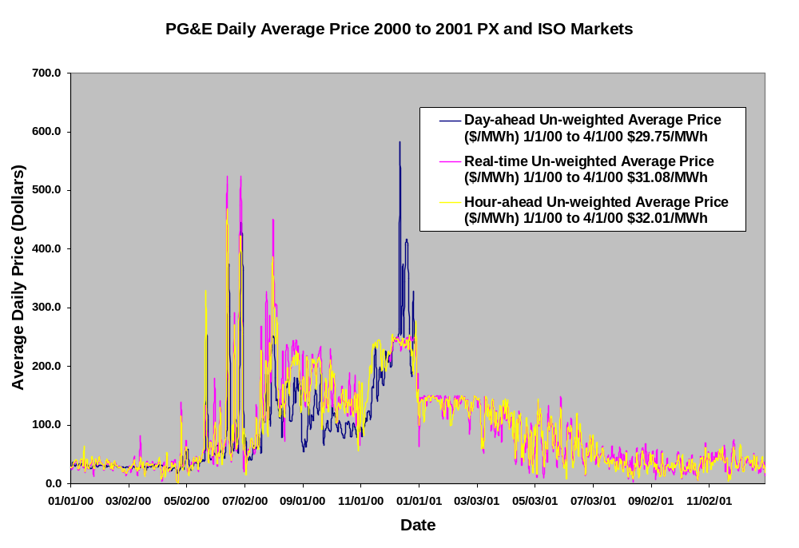 Figure 1
I have reviewed the other Parties submissions to discovery by California Parties' interrogatories. The data provided is inadequate to determine if individual Party's had the ability to pass the 20% market screen. And since no common format exists for the quarterly reports that were provided, it is impossible for me to do so. It is my testimony that all market participants in the wholesale markets regulated by the FERC must be ordered to provide their quarterly transaction data for the 2000 through 2001 period, in a common format, preferably Excel format, for quarterly reporting data to be useable to determine if individual sellers had control over 20% of the market at a given time and a given hub individually or in concert with other sellers of energy and ancillary services. It is further my testimony that the ALJ or Commission should order all sellers to provide all transactions for this period for all sales in the western markets cover by the WECC including the PX, ISO, and CERS, and any other contract for power. All sellers include PG&E and the other two investor owned utilities Southern California Edison Company (SCE) and San Diego Gas and Electric Company (SDG&E), all publicly owned utilities (POUs), any entity that sold energy and ancillary services in to the markets within the WECC.
Once this information has been provided by all market participants I will conduct similar analysis to that presented here for PG&E, and therefore I must conclude that the administrative record is not complete at this time and therefore not ready for hearings. Although as stated earlier I have reason to believe that in 2000 eight wholesale energy companies that purchased a third of California’s power plants after deregulation reaped some of the windfall profits through partnerships and gaming to exercise market power, but I lack adequate market participant quarterly transaction information to determine if this is true at this time. I request this information be provided prior to hearings.
Conclusions
A "bottomless pit" of unsecured debt was opened up worldwide when the Congress allowed unregulated banks to be created in 2000 in the Enron loophole. The "Enron loophole" exempted most over-the-counter energy trades and trading on electronic energy commodity markets from government regulation. The "loophole" is so-called as it was drafted by Enron Corporation lobbyists working with U.S. Senator Phil Gramm (R-TX) to create a deregulated market for their experimental "Enron On-line" initiative.The "loophole" was enacted in sections § 2(h)(3) and (g) of the Commodity Exchange Act, 7 U.S.C. as a result of the Commodity Futures Modernization Act of 2000, signed by U.S. president Bill Clinton on December 21, 2000. It allowed for the creation, for U.S. exchanges, of a new kind of derivative security, the single-stock future, which had been prohibited since 1982 under the Shad-Johnson Accord, a jurisdictional pact between John S. R. Shad, then chairman of the U.S. Securities and Exchange Commission, and Phil Johnson, then chairman of the Commodity Futures Trading Commission. On June 22, 2008, then U.S. Senator Barack Obama proposed the repeal of the "Enron loophole" as a means to curb speculation on skyrocketing oil prices. In the first half of 2008 the notional amounts outstanding of over-the-counter (OTC) derivatives continued to expand. Notional amounts of all types of OTC contracts stood at $683.7 trillion at the end of June 2008. In order to keep the world from falling in to a bottomless pit of unsecured debt we must re-assess everything (including the value of energy) to get rid of all the fraud in the valuation in everything we own purchase or sell. I call it my campaign to re-value the world.
The California Parties should not be allowed to serve two masters, the electric consumers and the electric utility CDWR. CERS is a division of CDWR formed in January 2001 to make energy purchases as the supplier of last resort to serve California citizens after sustained exercise of market power had driven California’s two largest utilities to the brink of insolvency and an additional 6.6 billion was taken from the state's general fund to keep the lights on in California. This harmed CARE's members when CDWR "crammed" additional surcharges on utility customer bills starting in 2001. CARE has filed a Complaint against CDWR for adding forty three billion in charges on California ratepayers' utility bills without their authorization; with the Federal Trade Commission. Those harmed include CARE members, specifically those members who are low-income and people of color, a protected class of customers who had their utility service turned-off because of the exorbitant rates charged. CARE members include residents of the surrounding states of Washington, Oregon, Nevada, Arizona, and New Mexico.
Denying CARE access to one consolidated evidentiary record this denies the ratepayers the opportunity for a fair hearing before the FERC and it deprives CARE's members of their constitutional rights. CARE participated in these proceedings at its own cost the other parties had sufficient funds to pay for representation. CARE’s members, being the ratepayers who were charged and paid the exorbitant rates had no paid representation. CARE's petition(s) for review include a request for remand of the FERC order because it refuses to provide funds for the electric and gas “end-user” to gain representation. FERC’s regulations include Rule 505.

DECLARATION OF
Michael E. Boyd
I, Michael E. Boyd, declare as follows:

1. I am a resident of Soquel California

2. My qualifications and experience are:
- I have a Bachelors of Science Degree in Physics from the University of California at Santa Barbara.
- I am currently unemployed as an Engineer/Scientist. My professional resume is attached.
- I am the President of CAlifornians for Renewable Energy, Inc. (CARE) a non-profit corporation under section 501(C)(3) of the federal tax code.
- As president of CARE I have participated as a formal Intervenor and as a witness before the State Energy Resources Conservation and Development Commission in numerous AFC proceedings.
- As president of CARE I have participated as a formal Intervenor and as a witness before the California Public Utilities Commission (CPUC) since 2003.
- As president of CARE I have participated as a formal Intervenor, a witness, and a complainant before the Federal Energy Regulatory Commission (FERC), since 2000.

3. I prepared the testimony to identify if there is any data that has been presented as a result of market participant quarterly transaction information provided to CARE in the EL02-71-017 proceedings to demonstrate if there is any evidence that the exercise of market power had taken place during the 2000 through 2001 western energy crisis, Docket EL02-71-017 et al.

4. It is my opinion that the attached prepared testimony is valid and accurate with respect to the issues that it addresses.

5. I am personally familiar with the facts and conclusions related in the attached prepared testimony and if called as a witness could testify competently thereto.

I declare under penalty of perjury, under the laws of the State of California, that the foregoing is true and correct to the best of my knowledge and that this declaration was executed at Soquel, California on June 30, 2009.
Respectfully submitted,
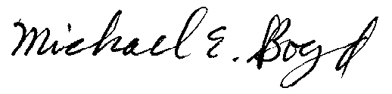
__________________________
Michael E. Boyd - President (CARE)
CAlifornians for Renewable Energy, Inc. 5439 Soquel Drive
Soquel, CA 95073-2659
Tel: (408) 891-9677
E-mail: michaelboyd@sbcglobal.net

I would like acknowledge Senator Barbara Boxer and her Legislative Assistant, Bridget Petruczok, who met with us, along with Senator Feinstein's staff Matthew Nelson who exchanged information with us about the FERC, as well as Congressman Sam Farr's Sr. Legislative Assistant, Troy Phillips, who spent considerable time discussing the FERC's intervener compensation program the day me and my attorney Martin Homec went to Washington DC on June 10, 2009 for Oral Arguments. We appreciate the two Senators' and Congressman Farr's continued support of our efforts before the FERC seeking refunds for overcharges incurred during the western energy crisis of 2000-01.
PG&E is one of the so-called California Parties.
Within the meaning given that term in section 796 (21) of title 16.
TITLE 42 CHAPTER 149 SUBCHAPTER XII Part E § 16471 § 16471. Consumer privacy and unfair trade practices (f) Definitions For purposes of this section: (1) State regulatory authority The term “State regulatory authority” has the meaning given that term in section 796 (21) of title 16. (2) Electric consumer and electric utility The terms “electric consumer” and “electric utility” have the meanings given those terms in section 2602 of title 16. TITLE 16 CHAPTER 46 § 2602 § 2602. Definitions As used in this Act, except as otherwise specifically provided— (1) The term “antitrust laws” includes the Sherman Antitrust Act (15 U.S.C. 1 and following), the Clayton Act (15 U.S.C. 12 and following), the Federal Trade Commission Act (15 U.S.C. 14[41] and following), the Wilson Tariff Act (15 U.S.C. 8 and 9), and the Act of June 19, 1936, chapter 592 (15 U.S.C. 13, 13a, 13b, and 21A). (2) The term “class” means, with respect to electric consumers, any group of such consumers who have similar characteristics of electric energy use. (3) The term “Commission” means the Federal Energy Regulatory Commission. (4) The term “electric utility” means any person, State agency, or Federal agency, which sells electric energy. (5) The term “electric consumer” means any person, State agency, or Federal agency, to which electric energy is sold other than for purposes of resale.
Residents of San Diego California faced complete deregulation in the summer of 2000.
Source: The Utility Reform Network (TURN). Calculation based on SCE and PG&E monthly and annual transition cost filings with the CPUC. This information does not include SDG&E’s stranded cost recovery.
On January 10, 2002, the California Attorney General filed suit against PG&E alleging that the company illegally siphoned money from the utility to the parent company.
See http://www.calfree.com/EL01-2FERCComplaint10-6-00.htm
See http://www.sen.ca.gov/ftp/sen/committee/standing/energy/_home/archive_hearings_1999-2000/AUDIT.HTM
PPL Montana, LLC is both a member of the Competitive Supplier Group, as well as the recipient of an individual motion to compel.
Motion at 10 (citation omitted).
Id. at 12.
California, ex rel. Lockyer v. British Columbia Power Exchange Corp., 122 FERC ¶ 61,260, at P 25 n45 (2008).
Id. at P 35.
California, ex rel. Lockyer v. British Columbia Power Exchange Corp., 125 FERC ¶ 61,016, at P 24 (2008).
California, ex rel. Lockyer v. British Columbia Power Exchange Corp., 122 FERC ¶ 61,260, at P 2 (2008).
California, ex rel. Lockyer v. British Columbia Power Exchange Corp., 125 FERC ¶ 61,016, at P 19 (2008).
California, ex rel. Lockyer v. British Columbia Power Exchange Corp., 122 FERC ¶ 61,260, at P 2 (2008).
The actual calculations can be viewed selecting the PG&E Report tab on the bottom left of the Excel spread sheet presented at the first cell in column B at the top left of the page.
Source: from PG&E's SEC filings from 1997 through 2001.
The actual calculations can be viewed selecting the PG&E Report tab on the bottom left of the Excel spread sheet presented at the first cell in column E the top in the middle of the page.
The actual calculations can be viewed selecting the PG&E Report tab on the bottom left of the Excel spread sheet presented at the first cell in column D at the top left of the page.
The actual calculations can be viewed selecting the PG&E Report tab on the bottom left of the Excel spread sheet presented at the first cell in column G the top in the middle of the page.
The actual calculations can be viewed selecting the PG&E Report tab on the bottom left of the Excel spread sheet presented at the first cell in column C at the top left of the page.
The actual calculations can be viewed selecting the PG&E Report tab on the bottom left of the Excel spread sheet presented at the first cell in column F at the top in the middle of the page.
Jickling, Mark (2008-07-07). "The Enron Loophole". Congressional Research Service. http://assets.opencrs.com/rpts/RS22912_20080707.pdf.
Mother Jones, http://www.motherjones.com/politics/2008/05/foreclosure-phil
"Obama vows crackdown on energy speculators: McCain fires back after Democrat tries to tie rival to 'Enron loophole" Associated Press 2008-06-22. http://www.msnbc.msn.com/id/25318274/
See http://www.bis.org/publ/otc_hy0811.pdf?noframes=1 at page 5.
EPACT § 1287. “Slamming” (changing providers on behalf of a customer without consent) and “cramming” (selling unwanted goods and services to an electric consumer) are specifically mentioned as areas of possible FTC rulemaking. TITLE 42 CHAPTER 149 SUBCHAPTER XII Part E § 16471 § 16471. Consumer privacy and unfair trade practices (c) Cramming The Federal Trade Commission may issue rules prohibiting the sale of goods and services to an electric consumer unless expressly authorized by law or the electric consumer.
Re: Complaint has been submitted Friday, January 23, 2009 10:29 AM From: "Michael Boyd" <michaelboyd@sbcglobal.net> To: "Martin Homec" <martinhomec@gmail.com> Martin, I talked to FTC about my complaint against DWR this morning. The new reference number is 21464102. I filed a complaint against DWR, California Energy Resources Scheduling,3310 El Camino Ave.,P.O. Box 219001, Sacramento, CA 95821-9001 (916)574-1291 I filed a claim for cramming DWR charges on bills for electricity consumers of PG&E, SCE, & SDG&E without our authorization first. MB-CARE --- On Fri, 10/31/08, no-reply@consumersentinel.gov <no-reply@consumersentinel.gov> wrote: From: no-reply@consumersentinel.gov <no-reply@consumersentinel.gov> Subject: Complaint has been submitted To: michaelboyd@sbcglobal.net Date: Friday, October 31, 2008, 9:40 AM Complaint Submitted Thank you for contacting the FTC. Your complaint has been entered into Consumer Sentinel, a secure online database available to thousands of civil and criminal law enforcement agencies worldwide. Your reference number is:20730735 If you want to update your information or have any questions, please call our Consumer Response Center, 1-877-FTC-HELP. Keep your reference number handy
18 CFR § 385.505 Right of participants to present evidence (Rule 505), Consistent with the provisions of this part, a participant has the right to present such evidence, including rebuttal evidence, to make such objections and arguments, and to conduct such cross-examination, as may be necessary to assure true and full disclosure of the facts.

